SDLC Models :
Agile model :
The Agile Model is a modern, flexible, and iterative approach to software development. Instead of building the entire software at once, the project is divided into small increments called sprints (1–4 weeks). Each sprint delivers a working part of the software.
Key features of agile model are as follows :
- Iterative and Incremental Development: Agile promotes iterative development cycles, with each iteration producing a potentially shippable increment of the software. This allows for rapid adaptation to changing requirements.
- Customer Collaboration: Regular and close collaboration with customers and stakeholders is integral to Agile. Their feedback is sought throughout the development process, ensuring that the product meets their expectations.
- Adaptability to Change: Agile embraces change, even late in the development process. It recognizes that requirements are likely to evolve, and the methodology is designed to accommodate these changes efficiently.
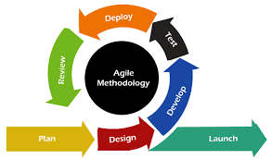
- Cross-Functional Teams: Agile encourages the formation of cross-functional teams comprising individuals with diverse skills. This promotes collaboration and enables the team to collectively take ownership of the entire development process.
Advantages of Agile Model:
- Faster time-to-market due to incremental releases.
- High client satisfaction because feedback is continuously implemented.
- Reduced risk because issues are identified early.
- Improved software quality through continuous testing.
- High transparency between client and team.
The Agile model, with its focus on collaboration, adaptability, and customer satisfaction, has revolutionized the software development landscape. As organizations strive for agility and responsiveness in a rapidly changing world, the Agile model remains a cornerstone for achieving success in software development projects.
Waterfall Model :
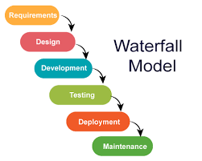
The Waterfall Model is a traditional and linear software development approach. Development flows step-by-step, and each stage must be completed before the next one begins—like water flowing down a series of steps.
Key features of waterfall model are :
- It starts with complete requirement gathering, where all needs must be clearly known at the beginning.
- Once requirements are locked, the team moves to system design, preparing architecture, data flow, and system structure.
- In the implementation phase, developers write code strictly based on the design without deviating.
- After coding, the software goes through an intense testing phase to find defects.
- Once tested, it moves to deployment, and later maintenance handles updates or fixes.
- It is easy to manage due to its structured flow but not flexible, because changes are very hard to implement after the project has progressed.
It is used for small or medium projects with clearly defined and stable requirements.
V- Model :
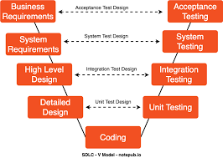
The V-Models, also known as the Verification and Validation models, is an extension of the traditional Waterfall models. It introduces a parallel testing phase for each corresponding development stage, forming a V-shaped diagram.
Key features of V- model are :
- On the left side of the “V”, verification activities take place such as requirement analysis, system design, and architecture design.
- On the right side, testing activities verify the corresponding development outputs.
- For example, requirements are matched with acceptance testing and architecture design is validated by integration testing.
- Testing is not postponed to the end; instead, it is planned early.
- The focus is on high quality and defect prevention, making it ideal for critical software.
Projects where zero failure is acceptable such as healthcare systems, aviation software, and defense applications.
Spiral Model :
The Spiral Model is a combination of the Iterative Model, Waterfall Model, and Risk Analysis. Development progresses through spirals, where each spiral is a mini-project consisting of planning, risk evaluation, development, and testing.
Key features of spiral model are :
- Begins with planning, defining objectives and constraints.
- Next is risk analysis, where potential technical or business risks are identified and mitigation is planned.
- Then a prototype or partial system is developed.
- Testing and customer evaluation happen at the end of each spiral.
- The cycle continues, adding new features in each spiral until the full system is complete.
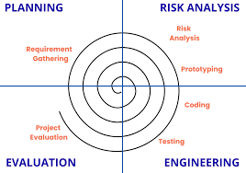
- Strong focus on risk management, making it suitable for large and uncertain projects.
Large-scale, expensive, or mission-critical projects (banking systems, complex government projects).

